**Step to Form Development**

* While starting the form development we should use TEMPLATE.fmb. Which is provided by the oracle. It has the standard libraries need to be loaded in the basic form. So we will start with the TEMPLATE.fmb. form location as follows.

**Please down load the file into our Desktop.**

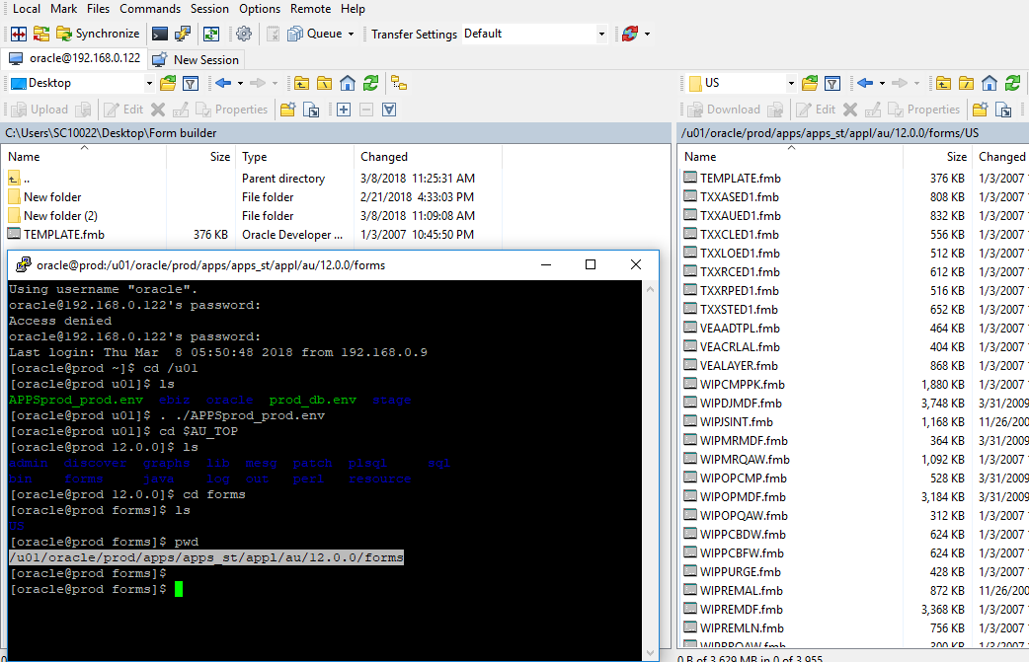

|  |  |
| --- | --- |
| Server | Application Server |
| Path | $ AU_TOP/form/US |
| File Name | TEMPLATE.fmb |

* Rename the TEMPLATE.fmb into some custom name like ‘XXSC_EMP_TEST.fmb’
* **Load the File into Form builder. it will be looks like as bellow.**

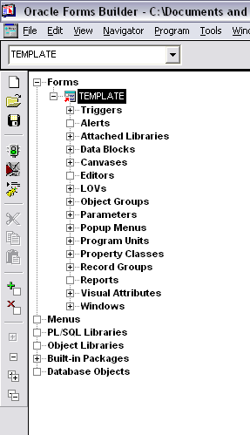

**Rename the TEMPLATE into ‘XXSC_EMP_TESTING’**

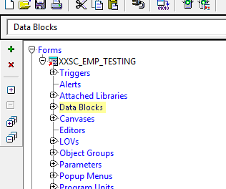

**Need to delete the Standard component in the form. Like standard Window, Canvas and Data block.**

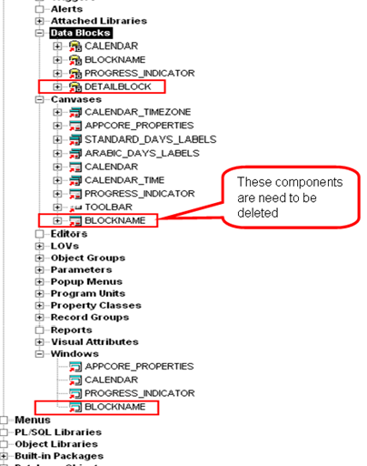

* **Need to create window for this form. Please follow the steps as bellow.**

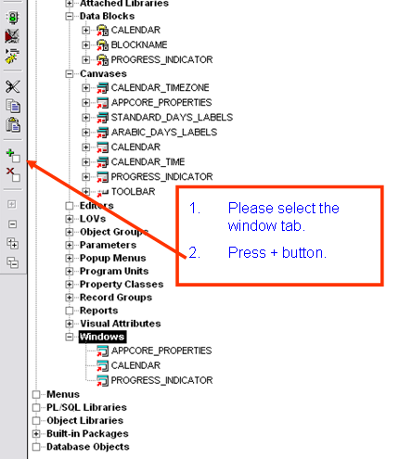

**Please right click in new window.**

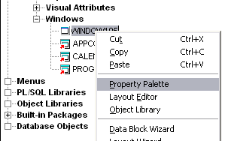

**Please select the following detail from the property palette.**

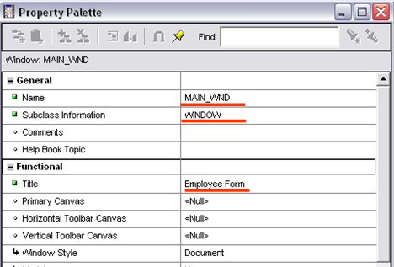

**Need to create a new canvas. For that please follow the bellow reference.**

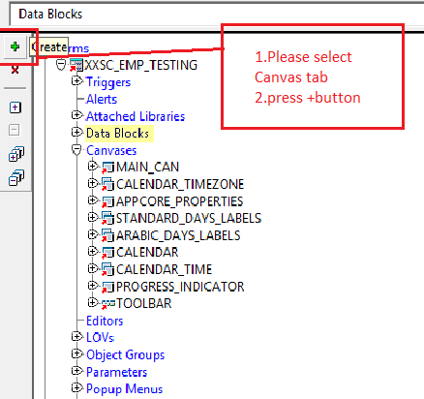

**Please select the property palette. And change values as bellow**.

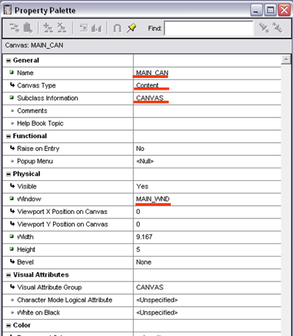

Create the table (XXSC_EMP_TAB) with using following table.

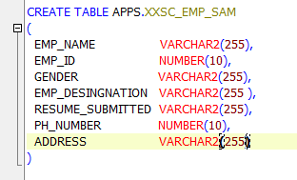

**Create a new data block.**

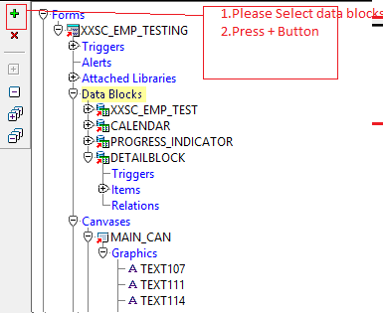

**Please select as follow**

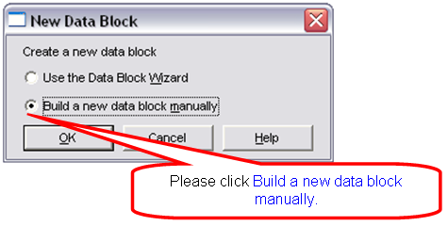

Please rename as follows XXSC_EMP_TEST.

Please select properties palette. As follow.

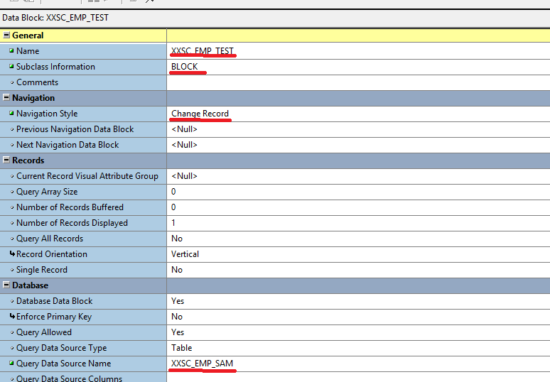

**Open the canvas drag and drop the items as bellow.**

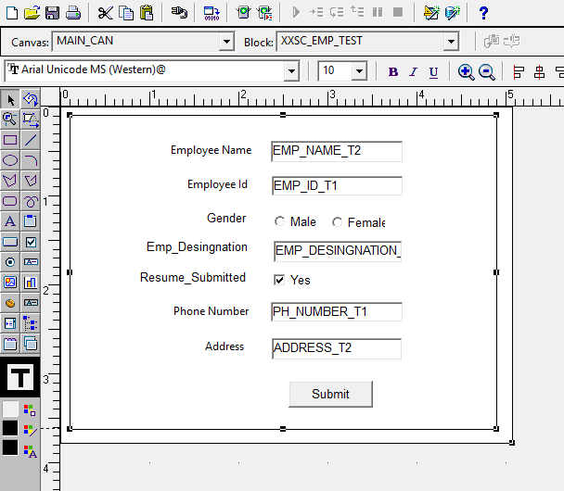

**Text Item**

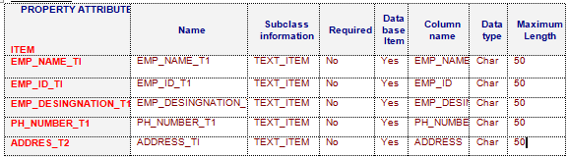

**Button**

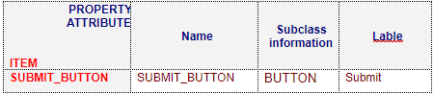

**Radio Button**

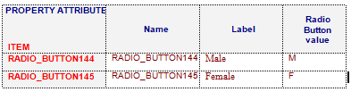

**Check Box**

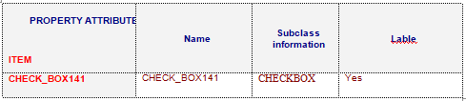

* Now we need to add Title into LOV. For validation purpose

We have titles table. With using table we have to create. We have to create a new Record Group.

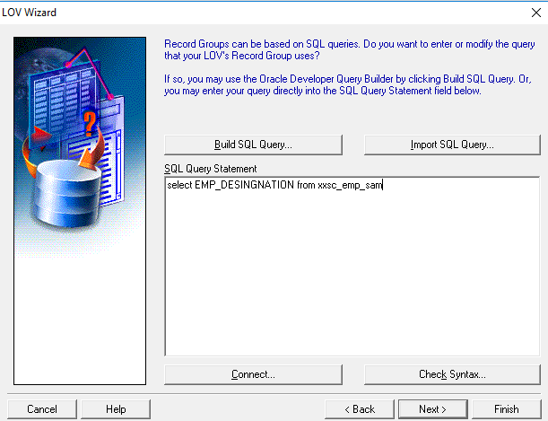

SQL Query:

|  |
| --- |
| select EMP_DESINGNATION from xxsc_emp_sam |

Change Properties:

Name : LOV149

* We have to create List Of Values(LOV) for this Record Group

Create a new LOV with build manually.

Set the properties

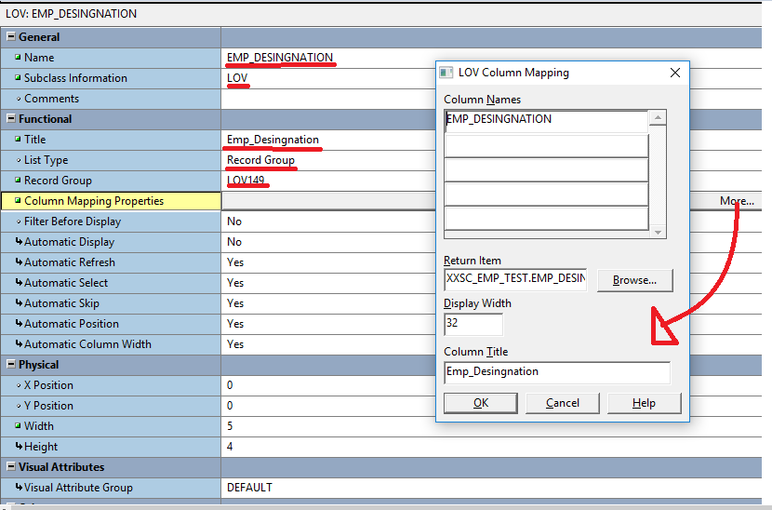

We have to map the LOV with text item which we have created for Title.

Change the properties:

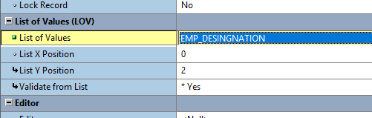

* Moving the form into Server. (SSD4)

Login into the Server and find out the Custom Path. For example $FND_TOP

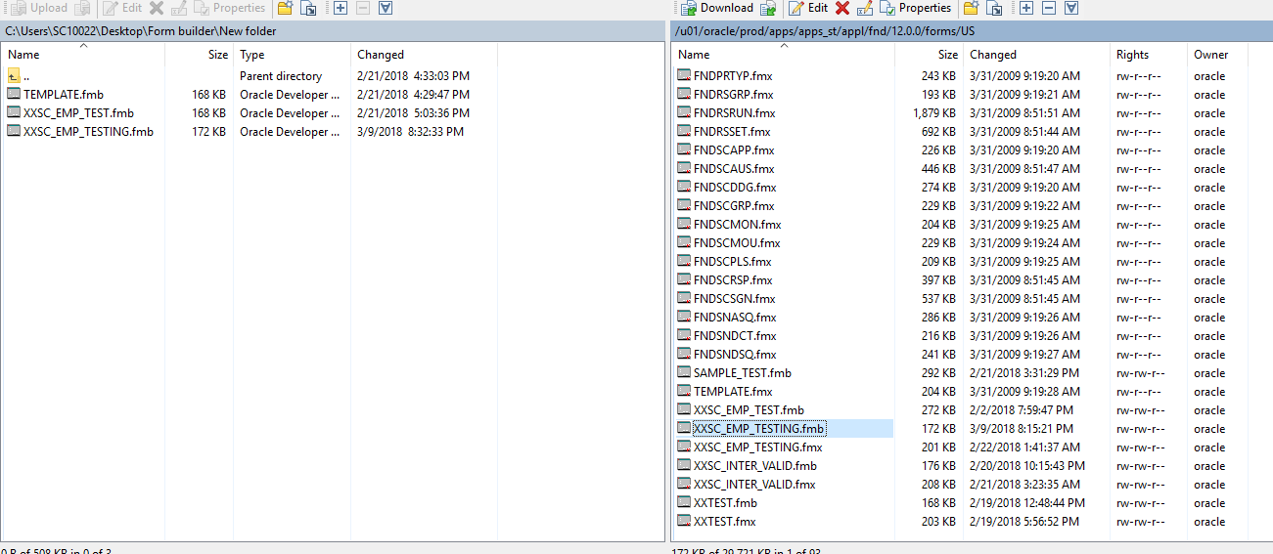

Compile form through following script. For that go to $AU_TOP and compile the form.

|  |
| --- |
| frmcmp_batch module=$AU_TOP/forms/US/XXSC_EMP_TESTING.fmb output_file=$AU_TOP/forms/US/XXSC_EMP_TESTING.fmx batch=no compile_all=special userid=apps/apps |

Below Confirmation After the form created.

Registering Form in our Server

Register Form.

Navigation**:-** Application Developer **->** Application **->** Form

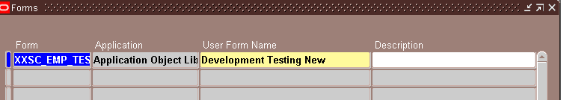

Register Functions.

Navigation**:-** Application Developer **->** Application **->** Function

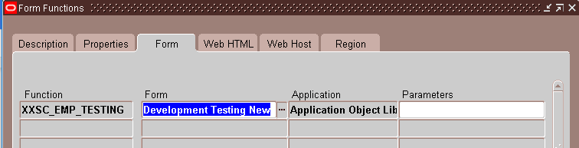

Attach with Menu.

Navigation**:-** System Administrator **->** Application **->** Menu

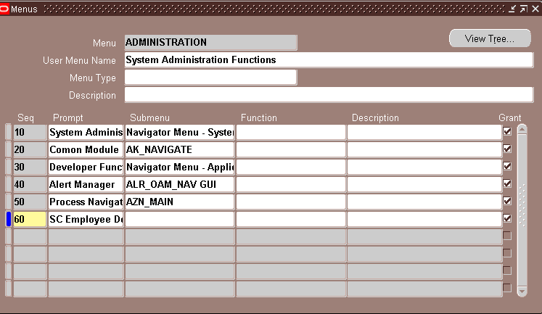

From front end. Responsibility **System Administrator**

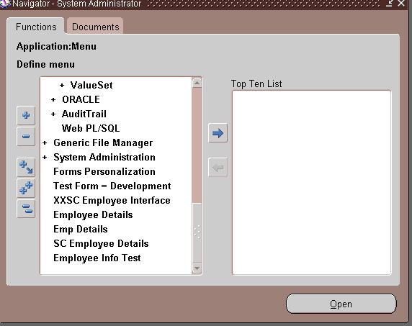

* Now we need to open the form for that we have to mention the Block Name and window name in the form.

Please write script as bellow. In APP_CUSTOM Package body.

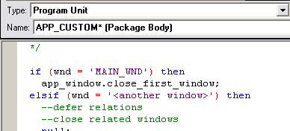

In Pre_Form trigger Please worte bellow script.

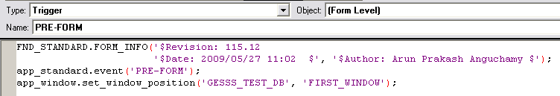

Now move the form and recompile the form in server.

.